NOTE

**Appendix 3: Diagnostics and model sensitivity**

Simulations confirmed the ability of this model to accurately estimate regional population trends (Figure S1)). Our simulations included realistic parameter values (i.e., we used fitted values from the empirical model) and sample sizes (i.e., the same sample sizes and number of stations as in our empirical data). Simulations also included the same amount of missing data (for both migration counts and breeding origin assignments) as in the empirical data.

We generated 100 independent simulated datasets (each 18 years in duration), wherein we generated stochastic population dynamics within each region using fitted variance components from spring migration for Blackpoll Warbler, while also simulating random values of between -0.2 and 0 within each stratum in each simulation. Observed counts at each station were simulated conditional on the simulated annual abundance in each region, migration probabilities from each region to each station, and process/observation variance components at each station.

We then fit the statistical model to the simulated data for each Monte Carlo run, and extracted estimates of stratum-level trends across the 18 years of simulated data to compare to the true (i.e., simulated) trends.

Bias in estimated trends was close to zero, and 95% credible interval coverage was nominal, indicating that the parameters are identifiable with realistic parameter values and data availability.

**Figure S1.** Comparison of actual (i.e., simulated) and estimated trends (i.e., by applying our statistical model to simulated data) in each of three strata for 100 simulations. Diagonal gray line indicates 1:1 relationship. Black dots indicate simulations in which 95% credible intervals did not contain the true value. Coverage is the proportion of simulations for which 95% credible intervals on the stratum-level trend contained the true (i.e., simulated) trend in that stratum.

**Figure S2.** Bayesian p-values associated with each station-year in fall (top) and spring (bottom) Bayesian p-values represent the proportion of simulated datasets using fitted parameter values that have higher root mean squared error (RMSE) than the actual data. Bayesian p-values close to 0.5 indicate that the RMSE of simulated data is indistinguishable from that in actual data. Values close to 0 indicate the actual data has higher error than the simulated data; credible intervals on model estimates may be too narrow in these cases. Values close to 1 indicate the actual data has lower error than the simulated data; credible intervals on model estimates may be too narrow in these cases. Gray bar ranges from 0.2 to 0.8, and values inside this range are considered to indicate “adequate” model fit. Values greater than 0.1 and 0.9 indicate relatively poor model fit for those stations in those years.

**Figure S3.** Relationship between predicted and observed total annual counts of Blackpoll Warblers at all station-years contributing migration counts to this analysis; fall on top, spring on bottom. Uncertainty in predictions is indicated with gray 95% credible intervals. Diagonal black line indicates 1:1 relationship. A close correspondence of predicted and observed values along the 1:1 line indicates a good model fit.

**Figure S4** Relationship between predicted and observed total annual counts of Blackpoll Warblers at stations contributing migration counts to this analysis, broken down by individual stations. Fall on top, spring on bottom. Uncertainty in predictions is indicated with gray 95% credible intervals. Diagonal black line indicates 1:1 relationship. A close correspondence of predicted and observed values along the 1:1 line indicates a good model fit.

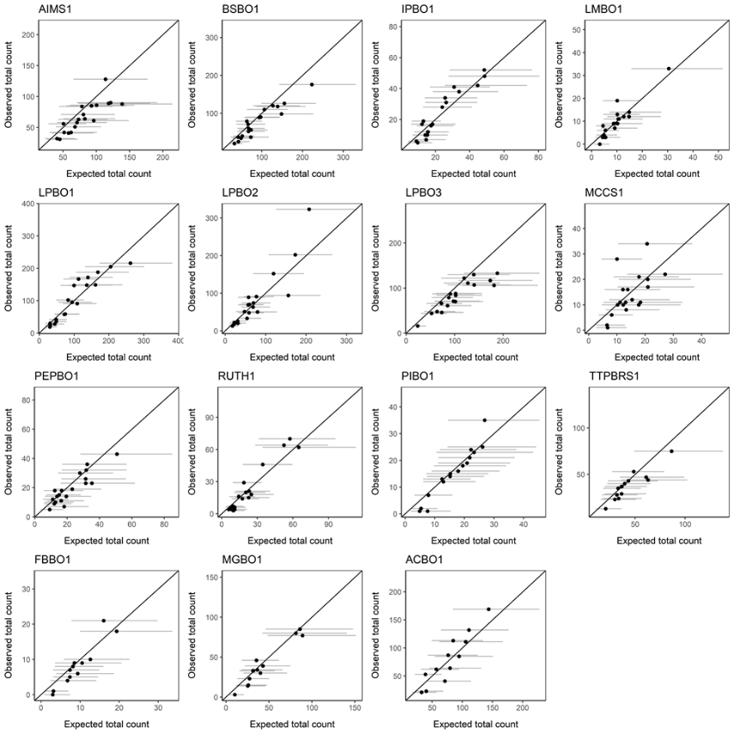

**Figure S5.** Annual indices of abundance () at each migration monitoring station across the full time series (2000 – 2018). Fall on top, spring on bottom.

Figure S6. Annual indices of abundance calculated as using equation 3 in main text. Post-breeding on top, pre-breeding on bottom. Error bars are 95% equal-tailed credible intervals. Median estimates of regional composition are shown by bars.

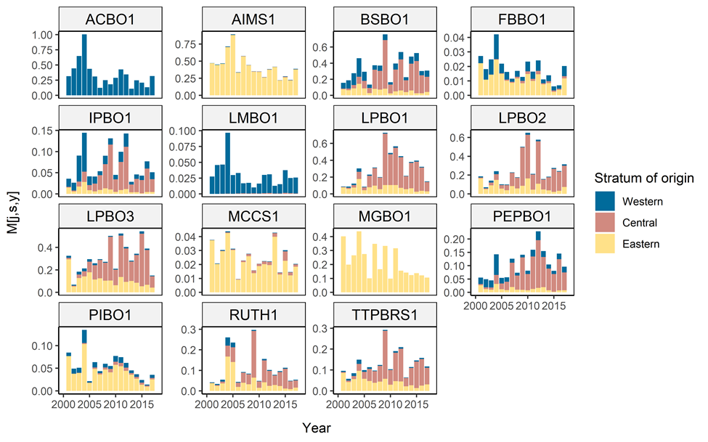

**Figure S7.** Estimates of annual growth rates (percent change between adjacent years) within each stratum based on the fitted model from migration monitoring, for all years in the full time series (2000 to 2018). Fall on top, Spring on bottom

**Figure S8.** Estimated trajectory of Blackpoll Warbler abundance within each analytical stratum over entire time series (2000-2018). Fall on top, spring on bottom.

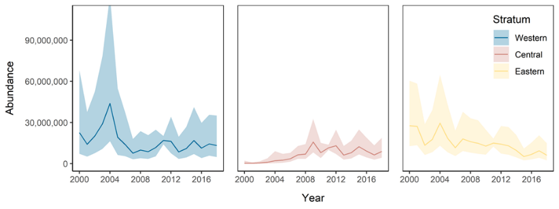

**Figure S9.** Estimated trajectory of Canadian national Blackpoll Warbler abundance over entire time series (2000-2018), based on fall migration monitoring (top) or spring (bottom).

